DIRECTIONS
COMING FROM EASTERN MASSACHUSETTS:
Take Rt. 2 West to Gardner Exit 86 (old exit 22), Rt. 68. Go around rotary to route 68 South. You will make a left hand turn on to Crawford Street at Burger King. Follow to the end of the street and turn left onto Mechanic Street. The Cataract and Laser Center is the last building on the left. Entrance is towards the back part of the parking lot.
COMING FROM WESTERN MASSACHUSETTS:
Take Rt. 2 East to Gardner Exit 86 (old exit 22), Rt. 68 South. You will be taking a left onto Crawford Street at Burger King. Follow to the end of the street and turn left onto Mechanic Street. The Cataract and Laser Center is the last building on the left. Entrance is towards the back part of the parking lot.
FROM SOUTHERN N.H. AND WINCHENDON:
Take Rt. 12 South to Rt. 140 to Gardner. In Gardner, take Rt. 68 South towards
Hubbardston. Go 1/2 way around the rotary to Route 68 South. Take a left at Burger King onto Crawford Street. Follow to the end of the street and turn left onto Mechanic Street. The Cataract and Laser Center is the last building on the left. Entrance is towards the back part of the parking lot.
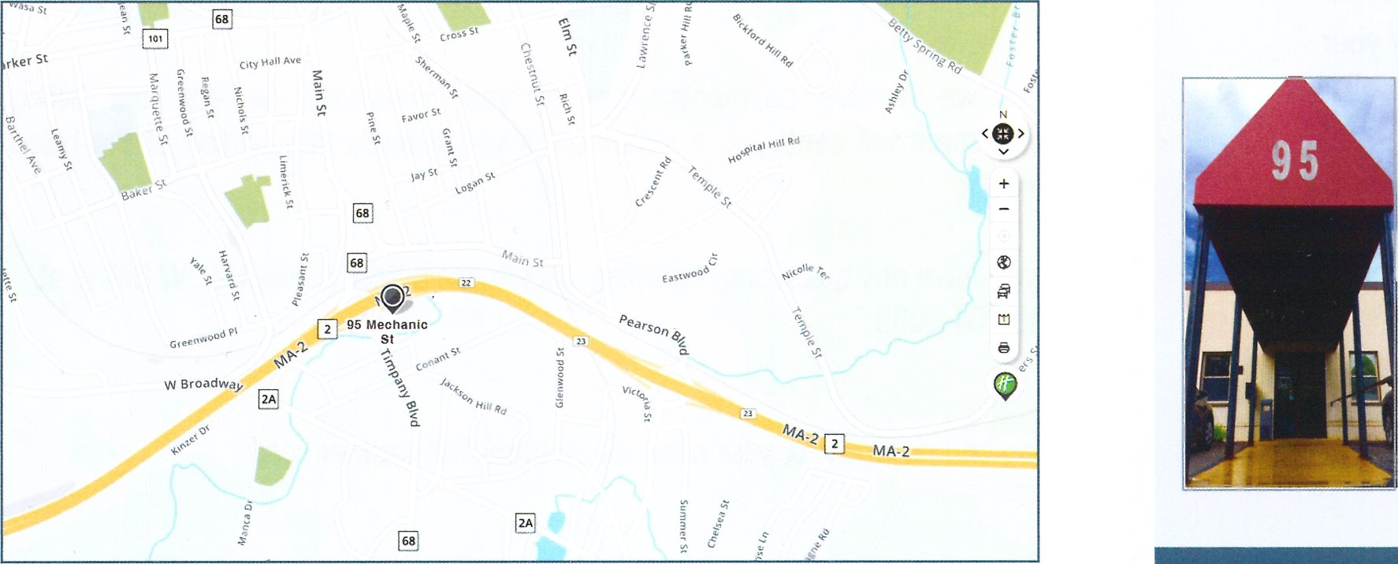
Cataract & Laser Center Central, LLC
95 Mechanic Street, Gardner, MA 01440 Telephone (978) 632-6674
Dear Surgical Patient,
The Cataract & Laser Center is the ambulatory surgery center where you will be having your upcoming surgery. The week before, we will call you with your arrival time and instructions for surgery. We are committed to your safety and well-being during your stay with us.
- We are staying healthy!
- We have enough personal protective equipment to keep our staff and patients safe.
- We have conducted training on social distancing and infection control.
- We have changed how we do things!
- We will be using the telephone for pre-registration and using the parking lot as our new waiting room. This will ensure that you are safe, and we can still provide services for you.
- We are committed to safety!
- During each day we clean and sanitize high touch areas. We don't allow visitors to our centers such as mail and delivery personnel. We screen every person who enters the facility regardless of whether they work for us or are having
surgery.
- We follow all CDC recommendations! Each evening, we do a deep cleaning of our facility and all patient areas with hospital grade cleaners.

PRE-OPERATIVE INSTRUCTIONS
- It is possible to be at the surgical center for 2-3 hours. There is preparation time prior to the surgery and recovery time after.
- You CANNOT DRIVE FOR 24 HOURS after your procedure. You will need to have transportation to and from the surgical center on the day of your surgery.
- You may take all your usual medication UNLESS your physician has directed you otherwise.
- Wear a loose fitting, comfortable shirt and close-toed, supportive shoes.
- If you wear false teeth or hearing aids, you can leave those in.
- On the day of surgery, do not use face lotion/creams, perfume/aftershave, or any makeup.
- Avoid wearing jewelry and watches, you may leave a wedding band on.
- Do not eat ANY solid foods after midnight day of surgery.
- You may have clear liquids (water, black coffee/tea, ginger ale, apple juice, cranberry juice) up to 2 HOURS prior to your scheduled arrival time.
A responsible adult should be with you for the first 24 hours after your surgery. If someone cannot be with you, please arrange for an adult to check on you frequently for the first 24 hours.
- Remember to bring your insurance co-payment (if applicable).
- For your comfort, bring a pair of sunglasses for after the surgery.

BILLING AND INSURANCE
As a result of your surgery, your insurance company(ies) will be billed by three providers:
- Your Surgeon - for your surgical and post-operative care.
- Cataract and Laser Center Central, LLC for the facility, nursing care, and medical supplies used during your surgery.
- The Anesthesia Group (Medical Circle of America), for the anesthesia services and staff.
The services provided at the Cataract and Laser Center Central, LLC are the same as those normally provided in a hospital. These services are referred to as a 'Facility Fee'. It is important to note that these fees are not included in the surgeon fees (enhanced packages, premium lenses or laser assisted cataract surgery) or the anesthesiology charges.
Prior to surgery you should check with your insurance company regarding your deductible, copays, and/or coinsurance. Insurance plans vary, it is best to call your company directly to get the most accurate and updated information.
After we receive payments from all your insurance carriers, our billing department will send you a statement if you owe us any portion of the billed amount.
If you have any questions regarding anesthesia billing, contact Amanda at:
774-745-5757.
You can now pay for your services at: https://clcgardner.com/

